COMMUNITY CHURCH OF WALKER
UNITED CHURCH OF CHRIST
P.O. Box 267, Walker, MN 56484 (218) 547-1093
www.uccwalker.com commchurchucc@arvig.net

“No matter who you are, or where you are, you are welcome here!”

“In an Earthenware Jar”
Sixteenth Sunday After Pentecost Year C
September 25, 2022 – 10:00 a.m.

Worship Leaders:
Pastor Michael Small
Liturgist: Deb Farrell
Greeter: Sonja and Ken Huber
Special Music: Ken and Linda Barber, Chris Kolp (Celebrate)
Musician: Leisa Bragg
Music Coordinator: Joanna Aamodt

Tech: Gary Jacobson, Aurora Diehl (Video), Esther Covert (Audio)
Marge Koch, Chancel and Communion Preparation

PRELUDE

WORDS OF WELCOME

A TIME FOR ALL OF GOD’S CHILDREN Deb Farrell

HYMN "Lead On Eternal Sovereign" (vss. 1 and 3) #573

CALL TO WORSHIP
One: Come to this place and time of promise.
All: We are becoming the house of hope,
the field of sunflowers,
the vineyard of great caring.
One: Come to a shared commitment
to abundance possible for all people.
All: We are an earthenware jar,
to keep safe the tomorrow of children.
Our security question is – the word of God,
and our password is love.

A TIME OF CENTERING
(During this time of centering, open your hearts to God; be in the present, here and now.)

PRAYER OF INVOCATION
One: God, we give you thanks that you make us redeemers, not just receivers of redemption. You bring us among friends and then ask for each one of our signatures to change your world. We hold the earthenware jar you call the church and fill it with all your promises. Amen.

PRAYER FOR TRANSFORMATION AND NEW LIFE
All: God, I have defaulted to un-hope in my life
and I have encouraged un-hoping in others.
I have criticized plans before hearing them out
and I have turned to family, church,
friends, colleagues with my face painted,
“we’ve tried that before
and it didn’t work.”
Together we have laughed at new ideas
and circulated only bad news.
Plant your promises deep in the field of our lives,
and forgive us our presuming to define your future. amen

(Observe a brief stretch of silence.)

WORDS OF GRACE
One: God wipes pessimism from the open heart and sends others to affirm in us even the most fragile possibilities of the future. We are forgiven.

PASSING THE PEACE (You may nod to your neighbors and say, “The Peace of Christ be with you” – Response “And also with you.”)

SPECIAL MUSIC “One Day at a Time” Celebrate
SCRIPTURE: Jeremiah 32:1–3a, 6–15
¹ The word that came to Jeremiah from YHWH in the tenth year of Zedekiah ruler of Judah, which was also the eighteenth year of Nebuchadnezzar:
² At that time the army of the ruler of Babylon was besieging Jerusalem, and the prophet Jeremiah was imprisoned in the court of the guardhouse attached to the residence of the ruler of Jerusalem. ³ Zedekiah the ruler imprisoned him after demanding, “How dare you prophesy the way you do?
⁶ The word of YHWH came to me and said, ⁷ “Hanamel, the son of your uncle Shallum, will come to you and say, ‘Buy my field in Anathoth. As next of kin you have the right of redemption to purchase it.’ ” ⁸ And just as YHWH foretold, my cousin Hanamel came to me in the court of the guardhouse and said, “Buy my field at Anathoth in Benjamin. You have the right of redemption to purchase it as next of kin. So why not purchase it?” I knew that that this was the word of YHWH.
⁹ So I bought the field in Anathoth from my cousin Hanamel, and weighed out the money—seventeen shekels of silver. ¹⁰ I signed the deed and sealed it, had it witnessed and then weighed out the money on a scale. ¹¹ I took the copies of the deed of purchase—both the sealed copy containing the terms and conditions and the unsealed copy—¹² and gave them to Baruch ben-Neriah ben-Mahseiah in the presence of my cousin Hanamel and of the witnesses who had signed the deed and all the people of Judah who happened to be in the court of the guardhouse. ¹³ I gave Baruch these instructions in their presence: ¹⁴ “Thus says YHWH Omnipotent, the God of Israel: Take these deeds, both this sealed deed of purchase and the unsealed deed of purchase, and put them in a clay jar so that they may be preserved for a very long time. ¹⁵ For this is what YHWH Omnipotent, the God of Israel, says: Houses, fields and vineyards will once again be purchased in this land.”

REFLECTION “In an Earthenware Jar”

HYMN “Precious Lord, Take My Hand” (all verses) #472

PRAYERS OF THE PEOPLE

THE LORD’S PRAYER (Unison, using debts)
Our Father, Who art in heaven, hallowed be Thy name; Thy kingdom come; Thy will be done on earth as it is in heaven. Give us this day our daily bread; and forgive us our debts as we forgive our debtors; and lead us not into temptation, but deliver us from evil. For Thine is the kingdom, and the power, and the glory forever. Amen.

INVITATION TO GENEROSITY
One: We are invited to offer resources, time, abilities, compassion, in a tangible expression of our hope for the future for ourselves, this community of faith and many others near and far away. I invite you to be generous, my friends, with your trust in the future.

SPECIAL MUSIC “Because He Lives” Celebrate
PRAYER OF DEDICATION AND THANKSGIVING
One: God, we have received hope; we give you time. We have received hope; we give one another the church. We have received hope; we offer these gifts that they may become the change or simply the promise of change among those who need this clear image that they are not abandoned. Amen
HYMN "God Be With You" (vss. 1 and 3) #81

PARTING WORDS
One: May you be as blessed as Jeremiah –
with a word-of-God whisper when you are waiting,
a glimpse of freedom when you are confined,
a friend to show you the way forward,
an earthenware jar of God’s love
in which your signature is precious.
Go in Peace! Amen.

HYMN “Will the Circle Be Unbroken” Celebrate and Congregation

Chorus:
Will the Circle be Unbroken by and by Lord, by and by?
There’s a better home a waiting in the sky, Lord, in the Sky.

In the joyous days of childhood, often told of wondrous love,
Pointed to the dying Savior, now they dwell with God above.

Chorus

You can picture happy gatherings ‘round the fireside long ago.
And you think of never parting. Will they leave you here below?

Chorus

POSTLUDE

In an Earthenware Jar: Service Prayers for the Sixteenth Sunday after Pentecost were written by Maren C. Tirabassi who is a UCC pastor, author of fiction and non-fiction, and also a hiker in autumn leaves and a lover of fireside moments in the company of dogs, reading poetry and novels and finding myself praying.

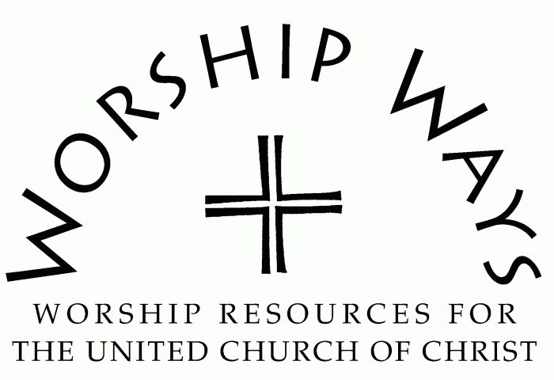

Copyright 2022 Faith INFO Ministry Team, 700 Prospect Avenue, Cleveland, OH 44115-1100. Permission granted to reproduce or adapt this material for use in services of worship or church education. All publishing rights reserved.

Due to Covid-19 It is recommended that:
We wear masks.
Keep distance from one another.
If you are feeling unwell, please stay at home!

Please join us for fellowship following the service in the Fellowship Hall.

The text here inserts “said Jeremiah,” to cue the reader that it is no longer Zedekiah speaking. In English, however, this suggests that the two are speaking in dialog, whereas what follows is apparently Jeremiah’s discourse to his disciples from prison.

